lab ASSIGNMENT aB31.2

printbylevel

Background:

1. A different kind of binary tree traversal scheme is to visit the nodes level by level. The task in this lab assignment is to print out a binary tree by level from left to right. For example, this binary tree of letters will result in the following output of letters:

M E R A J P T G N Q X H

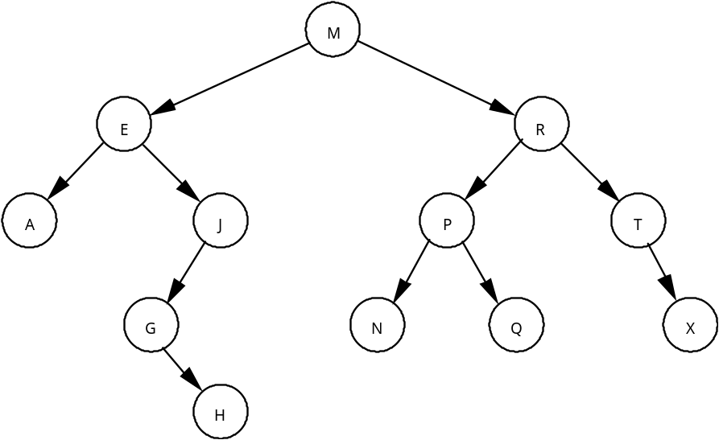

Assignment:

1. Use the Queue class to solve this problem.

2. Starting with the binary tree created in the previous Lab Assignment AB30.3, TreeStats, build a binary tree of characters ordered by letter.

3. Write a method printLevel that prints out the tree, level by level from left to right. The output can be formatted in one line as in the above example.

Instructions:

1. Use the same data files (fileA.txt) and (fileB.txt) that were used in Lab Assignment AB30.3, TreeStats.

